**TABLE OF CONTENTS**

1 INTRODUCTION 1

1.1 Problem Statement 1

1.2 Objective 1

1.3 System Scope 1

1.4 Target User 1

2 LITERATURE REVIEW 2

2.1 Introduction 2

2.2 Review on the Existing System 2

2.2.1 Exist 1 2

2.2.2 Exist 2 2

2.2.3 Comparison with the < New System Name> * 3

3 SYSTEM ANALYSIS 4

3.1 System Development Process 4

3.1.1 Project planning and oversight 4

3.1.2 System requirement analysis 5

3.2 System Modeling 5

3.2.1 Process Modeling 5

3.2.2 Logical Modeling 5

3.2.3 Data Modeling 5

4 SYSTEM DESIGN 6

4.1 The proposed screen/ page 6

4.2 Reports 6

4.3 Hardware/ Equipment Specification 6

4.3.1 Development 6

4.3.2 Distribution/ Implementation 6

5 IMPLEMENTATION / DEVELOPMENT PLAN 7

6 CONCLUSION 8

REFERENCES 9

APPENDICES 10

Appendix A 10

Appendix B 10

# INTRODUCTION

The development of technology, encouraging changes in human activity in various fields, one of the most rapid technological developments is information technology. In its development, information technology touches various fields. this is marked by many computer users both for personal interests, office, company or business even to the things that are entertainment and education.

Information is very important for the management in decision making, information can be obtained from the information system. The rapid development of information requires various agencies to make changes in an existing system, because the problems faced were growing.

One of the institutions that do a lot of information processing ie educational institutions. Problems that often occur with regard to information systems that usually takes a long time and the absence of accurate data or missing data required. Therefore it is a requirement for each school to improve the quality of the school, one of them is by developing academic information system, because with a good academic information system will make the process of data processing into an information becomes faster and efficient. Academic information system is a system used to perform data collection and data processing is good, neat and organized in an educational institution. Academic Information System is intended to facilitate each data search quickly. Academic Information System using data collection methods and data processing computerized student is intended to facilitate the administrative process both at the time of registration, class division and selection of homeroom. The computerized system can also make it easy to add new student data and the results can also be displayed automatically, accurately and in detail.

In the activities of Nurul Iman Junior High School and Vocational High School in conducting operational activities are still done manually. Both in the data collection of students, staff, schedule, assessment and other things in other operational activities.

Based on these problems, then the innovation will be done is to create a web-based academic information system. In order for the operational activities of Nurul Iman Junior High School and Vocational High School any data processing can be well organized. So that simplify the data access and delivery of information available.

## Problem Statement

Based on the background that has been described above, the author formulates few problem as follows:

1. How to make a good information system application?
2. How to implement information systems that can assist in school operational activities using web-based information system applications?

## Objective

The purpose of making this system is for the creation of an academic information system in SMP and SMK Nurul Iman-based website that is integrated with the programming language PHP and MySQL as a database by utilizing the Internet network.

And has several Benefits that can be obtained from making this system include:

1. With the existence of this information system the process of school operational activities can be organized well, and the process of data collection become faster and accurate.
2. With the existence of Information System-based website helps the school in the utilization of existing technology..

## System Scope

Limitations of the problem in making this system are:

1. Information system to be made based on website.
2. This system provides information on student and event of Indonesian student association in Ishikawa Japan
3. Admin of this system can only do its activities on web application.
4. This system can only be used by students who have been and are studying in Ishikawa Japan.

## Target User

The target users for this system are all student, teacher and staff of Nurul Iman Junior High School and Vocational High School.

# LITERATURE REVIEW

## Introduction

1. **Sistem Informasi**

The system is a collection of elements that interact to achieve a certain goal. According to Herlambang and Tanuwijaya (2005), the definition of the system can be divided into two approaches, namely approach by procedure and component approach. Based on the procedure approach, the system is defined as a collection of several procedures that have a specific purpose. While based on the component approach, the system is a collection of interrelated components to achieve certain goals.

Information is data that has been processed into a form that has meaning to the recipient and can be a fact, a useful value. So there is a process of transforming data into an information that is input, process and output. According to Herlambang and Tanuwijaya (2005), data are facts or events that can be numbers or codes. The data still has no meaning for its users. To be able to have meaning data processed in such a way that can be used by users. Results of data processing is what is referred to as information. In summary, information is data that has been processed and has meaning for its users. So that information systems can be defined as procedures used to process data so that it can be used by users. (Citra Indah Kurnia, Haryanto Tanuwijaya, Tri Sagirani: 2014)

***2.1.2 Web Service***

According to W3C, web service is an application component that communicates using open protocol. Web services are built to allow web applications to work together. With web services, web applications can publish their functions to the world. According to www.IBM.com Reresentational State Transfer (REST) ​​is a set of architectural principles that can be used to design web services that focus on system resources, including how resources are sent over HTTP protocols by various clients written in different programming languages. REST web service has 4 main principles

that is:

1. Using HTTP method explicitly. One of the main characteristics of the REST service is the explicit use of the HTTP method in a manner that follows the protocol as defined by Request for Comments (RFC) 2616.
2. Stateless improves performance and simplifies REST web application design service. This is because in the absence of a state server does not need to synchronize session data with client applications.
3. Expose directory structure. REST web service must have an intuitive and predictable Uniform Resource Identifier (URI). URIs are defined as a kind of self-interface documentation that requires little, if any, explanation or reference for developers to understand the instructions get related resources.
4. Exchange data using XML, Java Script Object Notation (JSON) or both.

## Review on the Existing System

Previous research has been conducted by Ahmad Khoirul Rijal (2010) under the title "Web-Based Academic Information System at Mts Al-Muawanah Curug District of Tanggerang District". The study discusses the academic system of schools based on WEB using RAD methodology. Therefore, this research is done to try to build web-based academic information system using the same methodology that is RAD method.Results from research conducted by Ahmad Khoirul Rijal using RAD methodology is an application of web-based academic information system on Mts Al-Muawanah.

# SYSTEM ANALYSIS

# SYSTEM DESIGN

Student Information System Application and student event in Indonesia Ishikawa Japan is a system that serves to perform data collection and provision of information about Indonesian students and activities made by the Association of Indonesian Students in Ishikawa Japan. This system will run on Android Applications and Web apps that are integrated with each other. The system has several important unit modules:

1. New Student Enrollment Module

This module provides registration forms that require new student identities such as personal data, family data, and educational data. To be able to access the student information as well as the event in this application, the student must be enrolled in the application as a student who is studying in Ishikawa Japan.

1. Student Information Search Module

This module provides data of students who are currently and have been educated in Ishikawa Japan along with their family data through the search feature by name, department and mentor for those who take the S3 degree.

1. Event Module

This module provides event information that is or will be held by the Indonesian Student Association in Ishikawa Japan, register to attend an event by giving QR code as registration code, and get the Certificate as a participant who has attended the event.

## The proposed screen/ page

## D:\Materi dan Tugas\Semester 8\Proposal TA\Design App\App\Splash Screen.png

Image

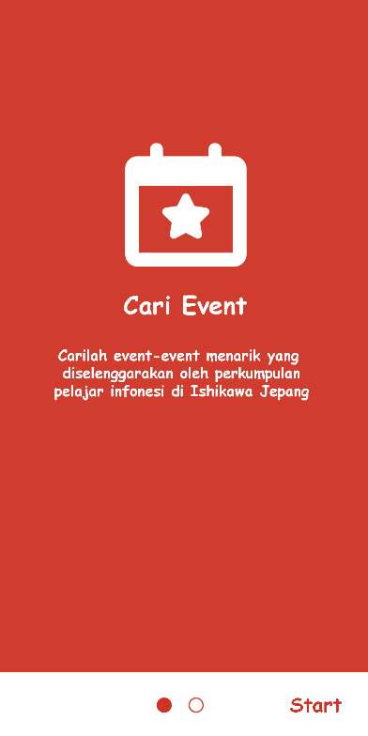

Image 4.1 *Tutorial Page*

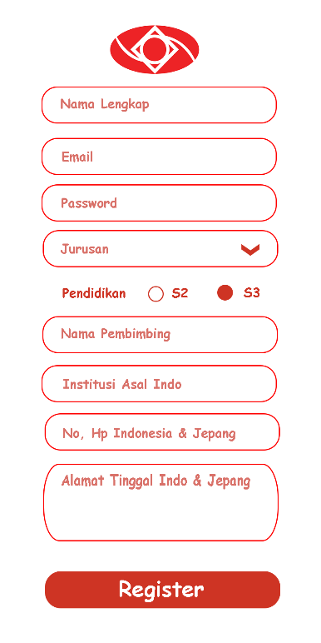

Image 4.3

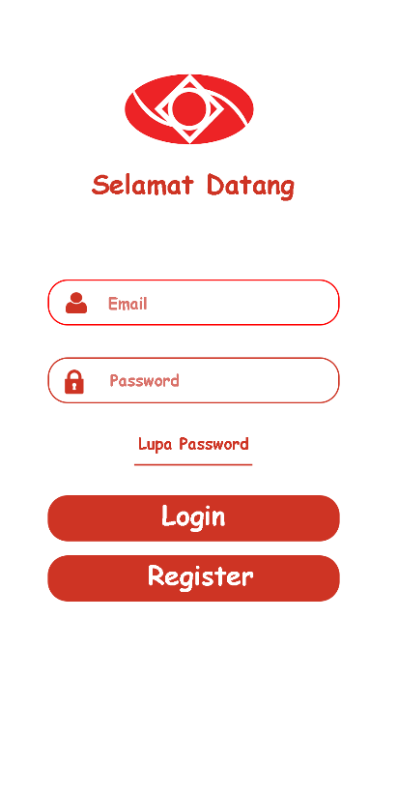

Image 4.4 Login Page

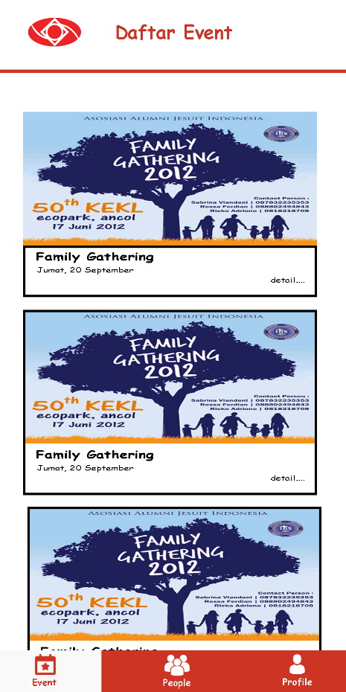

Image 4.5 Event Page

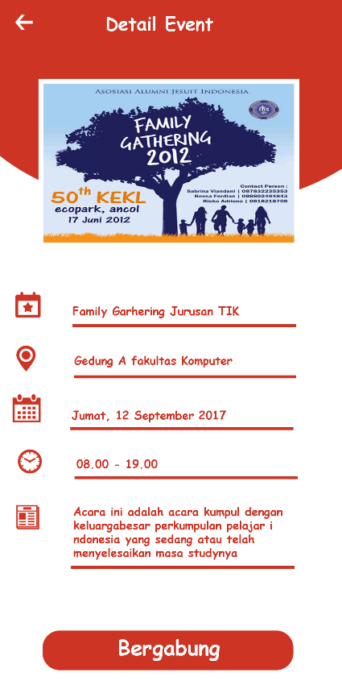

Image 4.6 Detail Evet

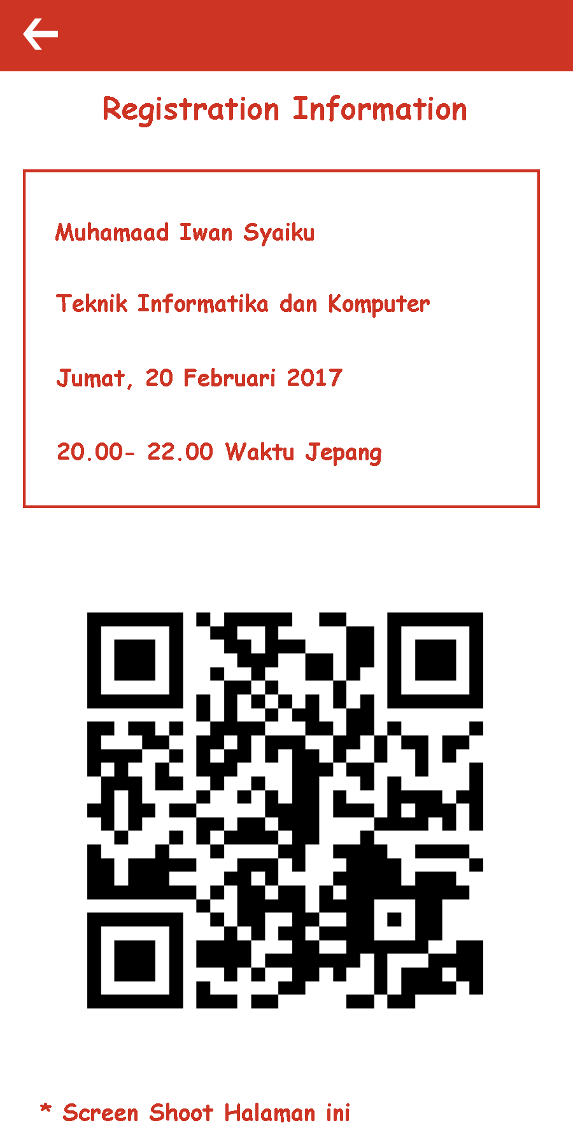

Image 4.7

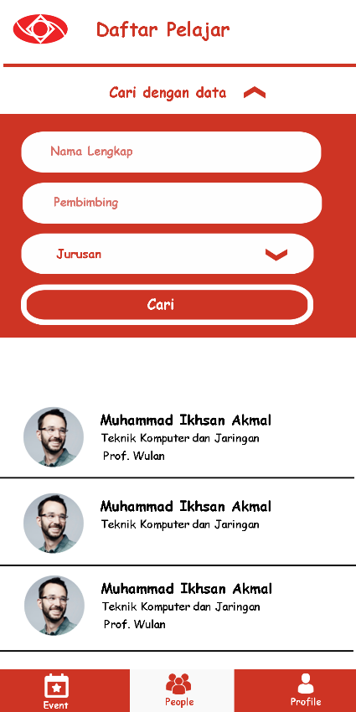

Image 4.6 Find People

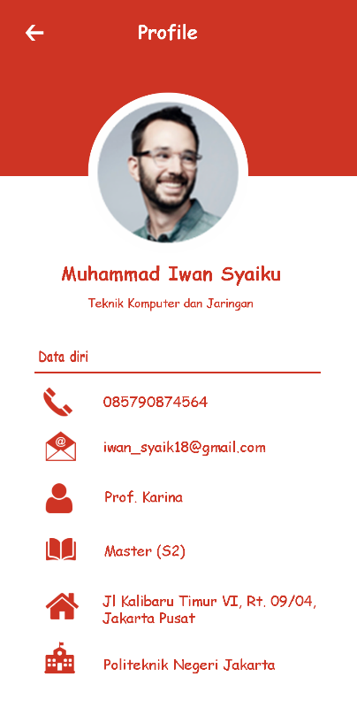

Image 4.8

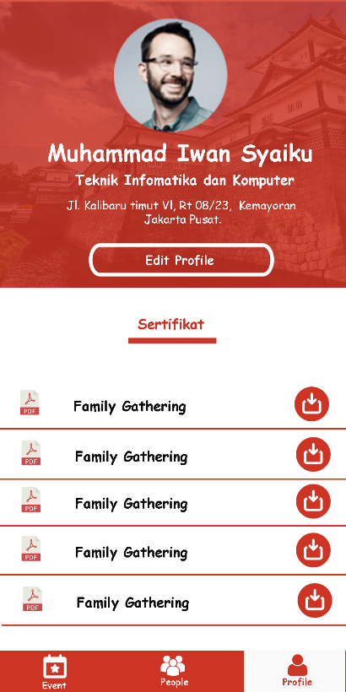

Image 4.9 Profile

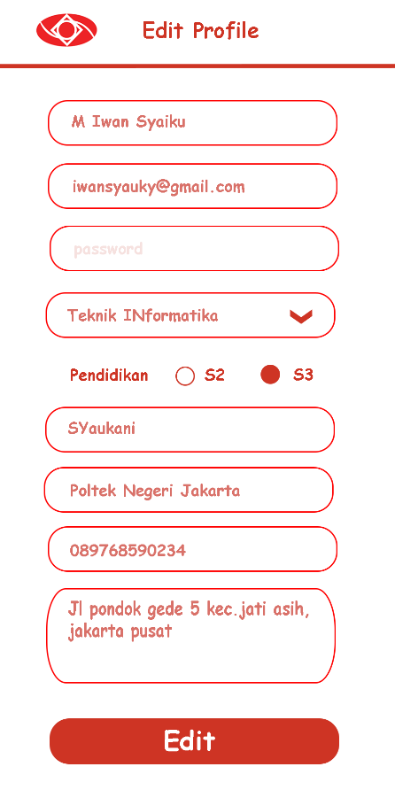

Image 4.5

## Reports

|  |  |  |  |
| --- | --- | --- | --- |
| **No** | **Task** | **Status** | **Comment** |
| 1. | One tutorial view once login |  |  |
| 2. | New account registration |  |  |
| 3. | One People one account |  |  |
| 4. | Getting link to update password |  |  |
| 5. | Login application |  |  |
| 6. | View all event on event menu |  |  |
| 7. | View detail event when click event in list |  |  |
| 8. | Getting QR Code and enrollment information when click Bergabung. |  |  |
| 9. | View all student information in find student menu |  |  |
| 10. | View profile when click student in list |  |  |
| 11. | View account information in My Account menu |  |  |
| 12. | Show list of certificate in My Account menu |  |  |
| 13. | Show page Edit Profile when click edit profile button in My Account menu |  |  |
| 14 | Show dialog success when update account succes in Edit Profile page. |  |  |
| 15. | Show dialog failed when update account failed in Edit Profile page. |  |  |

## Hardware/ Equipment Specification

### Development

|  |  |  |
| --- | --- | --- |
| No. | Device | Spesification |
| 1. | Alcatel One touch flash Plus | Processor : Mediatek Octa Core  Ram : 2 GB  Storage : 16 Gb  Graphich : Mali- T720 |
| 2. | Asus A451LN | Processor : i5 -4200U 1.6 Ghz  Ram : 8 GB  Storage : Seagate 1 TB  Vga : Nvidia GT 840M |
| 3. | BOLT Orion | Wi-Fi, 4g LTE, kecepatan 100 Mbps, MicroSD Slot, WiFi 802.11 a/b/g/n 2.4GHz, OLED Screen, 2000mAh |

### Distribution/ Implementation

|  |  |  |
| --- | --- | --- |
| No. | Device | Spesification |
| 1. | Canon EOS 760D Wifi Body Only Kamera DSLR - Black + Free LCD Screen Guard | * Sensor : APS-C (22.3 x 14.9 * mm) CMOS * Prosesor : Digic 6 * ISO :Auto, 100-12800 * (expandable to 25600) * Pixels : 24 megapixels * Ukuran layar : 3 Inch |

# IMPLEMENTATION / DEVELOPMENT PLAN

|  |  |  |  |  |  |  |  |  |  |  |  |  |  |  |  |
| --- | --- | --- | --- | --- | --- | --- | --- | --- | --- | --- | --- | --- | --- | --- | --- |
| **Job\Week** | 1 | 2 | 3 | 4 | 5 | 6 | 7 | 8 | 9 | 10 | 11 | 12 | 13 | 14 | 15 |
| Collecting Data |  |  |  |  |  |  |  |  |  |  |  |  |  |  |  |
| Analyzing and Modeling Data |  |  |  |  |  |  |  |  |  |  |  |  |  |  |  |
| Designing UI System |  |  |  |  |  |  |  |  |  |  |  |  |  |  |  |
| Making Proposal |  |  |  |  |  |  |  |  |  |  |  |  |  |  |  |
| Building application |  |  |  |  |  |  |  |  |  |  |  |  |  |  |  |
| Testing Sistem |  |  |  |  |  |  |  |  |  |  |  |  |  |  |  |
| Making Report |  |  |  |  |  |  |  |  |  |  |  |  |  |  |  |

# CONCLUSION

Technological developments are utilized by humans to assist them in performing every activity, almost all sectors of life are already using technology. One such sector is education. In the education sector is still needed a variety of technology supporting learning both in class and outside the classroom, one of the activities outside the classroom is the event and network of students. This application helps students in Ishikawa Japan to connect and get to know each other, they can find information of graduate students and students who are studying in Isikawa Japan. This application also helps students to invite and record students in Japanese ishikawa who want to follow the event held by the Association of Indonesian Students in Ishikawa Japan. With this system is expected to students in Ishikawa Japan can easily manage the event and alumni network of Indonesian students who attend school in Ishikawa Japan.

# REFERENCES

<<List of References @ citation here – APA styles>>

# APPENDICES

## Appendix A

## Appendix B